CONSULTATION RE SELBY DISTRICT COUNCIL LOCAL PLAN 2021

Background:
A Local Plan is a vision and framework for future growth of the Selby district, including identifying where new housing, employment and other development could take place.
For housing, National Government sets targets for the number of houses to be built, and the district council is legally required to produce a Local Plan that identifies sufficient sites to accommodate these.
In 2020 Selby District Council started preparation of a new plan to cover the period from 2023 to 2040. This started with a consultation on the issues and options. In summer 2020 land-owners were invited to submit any land to be considered for development. This allows the District Council to identify potential sites, before evaluating which of these potential sites are preferred. This takes into account a wide range of factors, from access to employment and services, through to flood plain and designations such as green belt.
The plan also considers what infrastructure investments are required to support the proposed sites.
From 29th January 2021 to 12th March 2021, the District Council will carry out a public consultation on the emerging plans and preferred sites.

Potential impact upon Stillingfleet
One of the proposals under the Local Plan is to develop a new town of up to 3000 units. Three potential locations have been identified for this development. The site to the south of Cawood Road between Stillingfleet and Escrick (shown in purple on the map below) is included in the draft plan as one of the three potential locations.
More details are on Selby District Council's local plan pages. To get to the potential implications for Stillingfleet click on the highlighted ‘Preferred Options Local Plan Consultation Document’. That takes you to ‘Issue Meetings’. Look for ‘Additional Documents’ then click on ‘Local Plan Preferred Option 22-12-2020 reduced item 60 pdf’. Pages 156 to 158 of that document relate to Stillingfleet.
For ease of reference part of those pages has been set out below.)

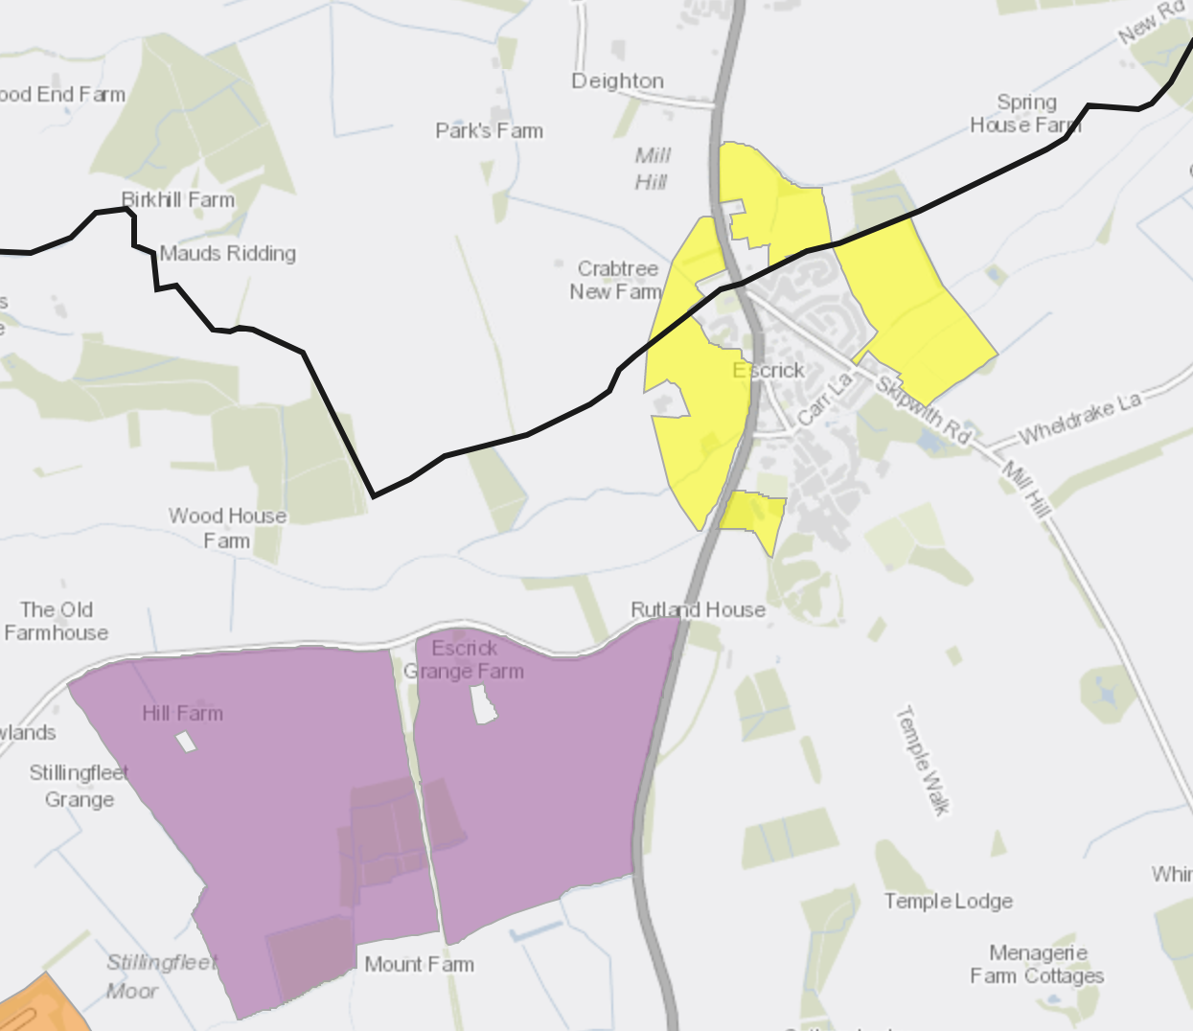

These are also shown on Selby District Council's site submission map

Next steps (January 2021)
Richard Musgrave, our Selby and North Yorkshire County Councillor will be attending our next Parish Council meeting on the 4th February to explain the preferred options in the consultation document and to answer questions about the possibility of a new town between Stillingfleet and Escrick.
The District Council will consult on its draft plan, including preferred sites, between 29th January 2021 and 12th March 2021, and residents have the opportunity to comment on the draft plan, including the evaluation of potential sites.
The Parish Council wishes to promote awareness and encourage residents to respond to the consultation which is underway. The Parish Council is seeking observations and comments from all Stillingfleet residents on these proposals in order to give a full and considered response. If you wish to share your views with the Parish Council please complete the response form below and email it to clerk@stillingfleetparishcouncil.org
Please note that the final day of the consultation period is the 12th March 2021.

Do you agree with the potential development of a new settlement between Stillingfleet and Escrick?

If not, please give the reason for your answer.

Which site do you think is the most suitable for a new settlement? Please rank them in order of preference.  1. Former Burn Airfield, Burn (BURN-G)  2. Land at Church Fenton Airbase (CFAB-A)  3. Land to the south of Cawood Road, Stillingfleet (STIL-D) | 1.  2.  3.
Please give the reason for your answer

STIL-D - Location: Land to the south of Cawood Road, Stillingfleet
Total Site Area: 173 hectares
Indicative dwelling capacity: up to 3,000 Dwellings (1,260 projected to be
built within the plan period)

Location and Ownership
The proposed site for a new settlement is located to the south west of Escrick Village to the East of the Former Selby Mine. The land is currently used for agriculture and is in single ownership. The site benefits from its proximity to the A19, with good road links to both York and Selby.

Constraints
Ancient Woodland
Overhead electricity lines
Requires improved road access to the A19
40% Grade 2 Agricultural Land (Grade 3 60%)

Opportunities
Predominantly Flood Zone 1;
Trans-Pennine Cycle Route which runs through the centre of the site, linking the new settlement to both York (12km) and Selby;
Links to existing communities at Stillingfleet and Escrick;
Relatively flat topography

Site Requirements
If this site were to go forward proposals should follow a comprehensive, phased approach to development in accordance with a masterplan which covers the development of the whole site and follows the 9 guiding principles for Garden
Villages. The Master Plan will be produced in consultation with stakeholders and the local community to inform the determination of any applications for development.

In addition development should:
1. Be developed in a coordinated way, in accordance with the approved masterplan in order to ensure that the appropriate infrastructure is delivered;
2. Provide an appropriate mix of dwelling types and tenures;
3. Development of the site must retain and enhance the section of the Trans-Pennine Trail which runs directly through the middle of the site, from north to south;
4. Should be fully integrated by cyclepaths and footpaths, which link residential areas to the local centre and employment land;
5. The site comprises significant areas of established woodland, including Heron
Wood, which should be retained as such. Where possible, well-established hedgerows should also be retained. The site must have substantial landscaped areas on its boundaries to safeguard the amenity of existing and future residents;
6. Provide 5ha of employment land;
7. Provide vehicular access to the site from both the A19 and B1222, including the provision of a new roundabout on the A19;
8. Provide green buffers to the site's boundaries; and
9. Provide opportunities for local employment and training schemes during the construction period.

