STILLINGFLEET PARISH

HOUSING NEEDS SURVEY REPORT FOR AFFORDABLE HOUSING
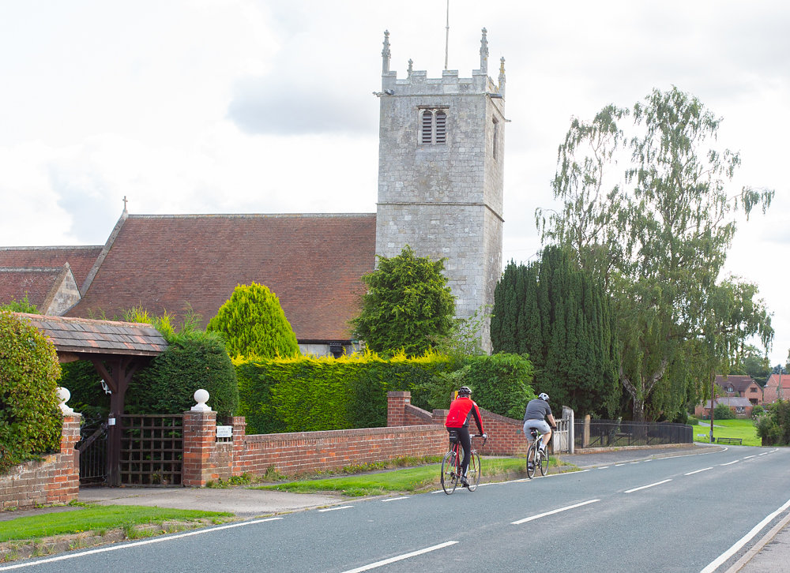

March 2022
Matthew Brown
Rural Housing Enabler
Selby District Council

Contents
1. PARISH SUMMARY 2
2. INTRODUCTION 3
3. AIM 5
4. SURVEY METHODOLOGY 6
5. HOUSING PROFILE OF STILLINGFLEET PARISH 7
5.1 Population 7
5.2 Dwelling Stock 7
5.3 House Prices 7
5.4 Private Rental Properties 8
5.5 Affordable Properties 8
5.6 Planning Applications 8
6. KEY FINDINGS FROM THE HOUSING NEEDS SURVEY 8
6.1 Local Connection 9
6.2 Main reasons for wanting to move 9
6.3 Household Composition 10
6.4 Existing Accommodation 10
6.5 Current Tenure 11
6.6 Current Household Income 11
6.7 Accommodation Needed 13
6.8 Preferred Tenure 14
6.9 Housing Register 14
6.10 Summary of HNS Findings 14
7. WHAT WOULD A LOCAL AFFORDABLE HOUSING SCHEME IN STILLINGFLEET MEAN TO RESPONDENTS 16
8. SUMMARY AND RECOMMENDATIONS 17
9. Appendix……………………………………………………………………………………………………………………………………..17

PARISH SUMMARY

Stillingfleet is a village and civil parish in the Selby District of North Yorkshire, England. Stillingfleet is located north of the urban settlement of Selby and bordered with the City of York and neighboring parishes such as Escrick.

Stillingfleet has a range of amenities such as a local village pub along with communities’ facilities such as two church and village institute.

Furthermore, Stillingfleet Parish has excellent nearby transport links to other locations such as York and Leeds with the close vicinity to the A64.

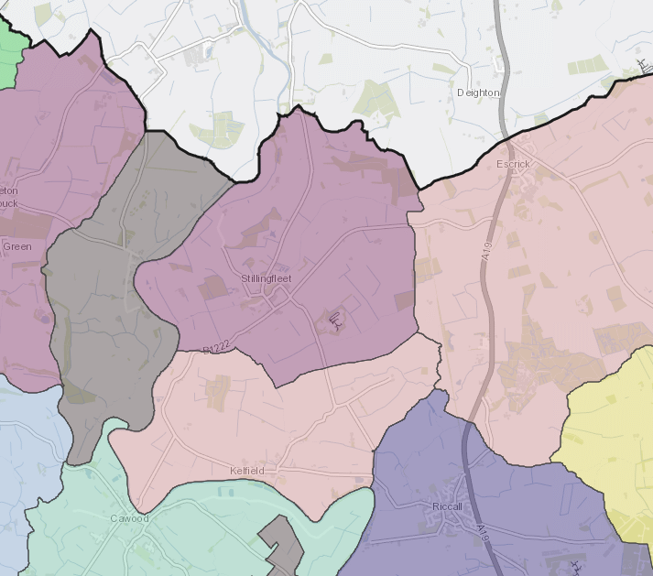

INTRODUCTION

Affordable Housing is housing for either rent or low-cost home ownership based on evidence of need for those unable to afford market prices. In order to help identify if there is a need for Affordable Housing, the Selby Rural Housing Enabler (RHE) has completed a housing need survey (HNS) in the parish of Stillingfleet. The RHE is hosted by Selby Council and is part of the wider North Yorkshire and East Riding Rural Housing Enabler Network. The RHE works with a range of organisations to help meet the housing needs of rural communities through the delivery of Affordable Housing.

Rural Housing Need Surveys record housing needs at a point in time and the RHE then uses this ‘snapshot’ of information as the basis of a report. This report can then be used as evidence to support a planning application for a small, local Affordable Housing development. In the event that any new homes are built, priority would be given to applicants with a local connection to the Parish (through family, residence, or work, at the time the properties are allocated).

AIM

The aim of the HNS is to find out whether local people (or people with a local connection) are in housing need and cannot access suitable housing to address their needs on the open market.

Housing ‘need’ can include issues other than merely the need for a home. It takes account of insecurity of tenure, affordability and housing that is unsuitable for the household due to its type or condition. It is different from housing demand because demand can normally be met though the housing market whereas need can usually only be met through some form of affordable (i.e., subsidised) housing.

This means that, in order to estimate the number of households in need, we want to identify households who do not have their own home or live in unsuitable housing and who cannot afford to meet their needs in the local market.

A household normally includes all who live in a particular house but can also include ‘newly forming’ households who currently live with a larger family/household (e.g., adult children living with parents).

SURVEY METHODOLOGY

In order to carry out the HNS, questionnaires with freepost return envelopes were distributed to every household in the Parish. The survey was distributed on 7th March 2022 with a deadline to return the questionnaire by 11th April 2022.
The survey was also promoted on Selby District Council’s website, Twitter, and Facebook pages. Survey forms could also be completed online. Completed questionnaires were returned to the RHE for analysis. (a copy of the survey form is at Appendix 1).

HOUSING PROFILE OF STILLINGFLEET PARISH

Population
According to the 2011 Census, Stillingfleet Parish has a population of 405 residents forming 152 households. The population of Stillingfleet Parish is generally healthy with 84.7% of residents indicating that their daily activities are not limited by their health. Whilst on the other hand, 4% of residents state that they have limiting long term illness or bad health.

Dwelling Stock

The Census data shows that 62.7% of households live in a detached property, with a further 25.3% living in a semi-detached property and zero living in a flat.

House Types | % Of households per property type
Detached | 62.7
Semi detached | 25.3
Terrace | 7.1
Flat | 0
Caravan or mobile home | 0
(Source –ONS)

In terms of tenure, 85.9% of homes in the Parish are owned outright or with a mortgage with a small percentage 7.2% private renting. In terms of affordable homes, there is only 0.2% shared ownership homes and 8.6% affordable rented.

Tenure Type | % Of households per property type
Owned outright | 41.5
Owned with mortgage | 36.8
Private rented | 7.9
Social/affordable rented | 10.5
Shared Ownership | 0.7

House Prices

At the present time, there are zero homes being advertised with a further eleven being sold or being subject to sale within the last 12 months, both sets of information are available in the table below. Properties in Stillingfleet had an overall average price of £590,363 over the last year. The majority of sales in Stillingfleet during the last year were detached properties, selling for an average price of £739,620. terraced properties sold for an average of £236,000.

Address | No. of beds | Property Type | Price | Added to Rightmove
Brimir, Escrick Road | 5 | Detached | £623,000 | 02/12/2021
Dales Court | 3 | Terraced | £273,000 | 28/09/2021
Catterick Cottage | 4 | Detached | £585,000 | 19/08/2021
Croft Cottages | 2 | Terraced | £205,000 | 21/07/2021
Dales Court | 3 | Terraced | £230,000 | 23/06/2021
Steward Lane | 5 | Detached | £1,000,000 | 21/04/2022
York Road | 5 | Detached | £850,000 | 07/06/2022
Pear Tree House | 5 | Detached | £800,000 | 07/06/2022
Church Hill | 5 | Detached | £570,000 | 09/06/2022
The Green | 4 | Detached | £550,000 | 09/06/2022
York Road | 3 | Detached | £525,000 | 03/06/2022
(Source - Rightmove)

Please note, there has been a surge in properties being advertised at present time due to the government’s reduction of Stamp Duty Land Tax as of 8th July 2020 until 30th September 2021 where properties up to £500,000 are not liable for Stamp Duty Land Tax.

Properties in Stillingfleet which could be potentially classed as affordable homeownership had an overall average price of £236,000 over the last year were all terraced houses with no detached being considered affordable.
In terms of comparison, properties sales in Stillingfleet were similar to neighbouring Naburn (£411,500), but was more expensive than neighbouring Riccall (£326,319) and Escrick (£392,700)

Private Rental Properties

At the present time (June 2022) there is zero private rental properties available to rent privately in Stillingfleet and zero recently been let either. (Source: Rightmove).

Affordable Properties

Within Stillingfleet, there is a total of 14 affordable properties with Selby District Council owning and managing 13 properties all at Social Rent of which there has only been two properties available in last 5 years. Furthermore, there is one being owned and managed by various affordable housing providers as a shared ownership.

Property Type | No of beds | Number of homes
Bungalow | 1 | 0
Flat | 2 | 0
House | 2 | 0
Bungalow | 2 | 6
House | 3 | 7
House | 4 | 0

Selby District Council housing stock breakdown

Right to Buy

Over the last 10 year period, one Selby District Council properites have been sold through right to buy with zero being replaced within the Parish of Stillingfleet.

Planning Applications

There have been 6 dwellings that have been completed in the Parish of Stillingfleet within last 5 years. Of the none of these have been affordable housing.
There are currently 16 permissions outstanding for Stillingfleet Parish which include no additional affordable housing.
In the recent New Local Plan consultation 2 sites were put forward including a proposed new settlement with no decision being made.

KEY FINDINGS FROM THE HOUSING NEEDS SURVEY

A total of 13 survey forms were returned by the deadline of 11th April 2022, 8 were paper responses and 5 were completed electronically with a total of 6 who have been identified as being in affordable housing need.

In addition to 2 forms which were retuned either blank or “no such address”

Only the 6 residents with identified affordable housing need will be analysed in the below sections.

Local Connection

All respondents specified a local connection as identified below with the majority already currently living in parish:

Main reasons for wanting to move

Respondents were asked to identify reasons for their current and future housing needs. The graph below shows the main reasons respondents gave for wanting to move home; demand is highest from respondents who are first time buyers (67%) with respondents who want a place of their own (50%) had the two biggest responses.

Existing Accommodation

Of respondents answering the question, relating to existing accommodation, 100% were currently living in houses, with no respondents living in a flat or living in a bungalow.

In terms of current bedrooms, the majority of those housed in three bed homes (84%) with smaller percentages of 16% in four bed homes.

Current Tenure

The current tenure of the households in the survey is shown in the chart below; most is living with family or friends (50%) with rented through council, private renting and owned with a mortgage (16%).

Current Household Income

The total annual/monthly gross combined income households are summarised in the table below.

Amount | Numbers
Under £20,000 household income per year  (Under £1,665 per month) | 0%
Between £20,000 and £29,999 per year  (£1,666 - £2,499 per month) | 80%
Between £30,000 and £39,999 per year  (£2,500 - £3,332 per month) | 0%
Between £40,000 and £49,999 per year  (£3,333 - £4,166 per month) | 20%
Between £50,000 and £59,999 per year  (£4,167 - £4,999 per month) | 0%
Between £60,000 and £69,999 per year  (£5,000 - £5,832 per month) | 0%

Not all respondents provided details of their income

As shown in section 5.3 above, the average sold price for an affordable property in Stillingfleet in the last year is £590,363. Therefore, based on the financial data available, one of the respondents had sufficient household income to afford the average purchase price in the Parish.

Of the households with sufficient income, however, one of the responded with a housing need stated they had the deposit of over £20,000. Further information, would be required to establish whether they had the requisite 20% deposit of £118,072

Ability to Afford to Purchase Alternative Housing
Of the 6 respondents, 2 indicated that they had saved a deposit to buy a home and provided the level of deposit (see table below) with one would have enough for the required open market deposit.

Funds (Savings) | Numbers
NIL | -
£0 - £4,999 | -
£5,000 - £9,999 | -
£10,000 - £14,999 | 1
£15,000 - £19,999 | -
Over £20,000 | 1

A typical deposit required to purchase a property is currently 20%. Referring to the three-bed terraced property at Dales Court, which was sold for £230,000, (see 5.3 on page 7), a deposit of £46,000 (20%), would be required to secure a mortgage. Purchasing on the open market is therefore not an option for the majority of respondents.

Accommodation Needed

The type and size of housing required by respondents is summaried in the graph below. Data indicates that need for two bed accomodation (3 households) and three bed accomodation (3 households) predominates.

What type of accommodation is required based upon the responses. The majority indicate that a house would be a preferred option (6 households) with no preference about having a flat or bungalow.

Preferred Tenure

The survey results show that respondends choice of tenure was to buy on the open market followed by renting from council or RP and private renting. However, of those who stated buying on the open market was a prefered tenure, none of those households had a deposit or earnings over £30,000.

Housing Register

Of the 6 respondents included in the analysis, only one stated they were registered on North Yorkshire Home Choice.

However, when conducting a demand report from North Yorkshire Home Choice, it has identified that there are currently 34 active applicants who have stated they wish to be rehoused within the Stillingfleet, Riccall and Kelfield

The table below provides a breakdown of the bedroom need:

Area | 1 Bed | 2 Bed | 3 Bed | 4 Bed | Total
Stillingfleet, Riccall and Kelfield | 26 | 11 | 8 | 2 | 47

WHAT WOULD A LOCAL AFFORDABLE HOUSING SCHEME IN STILLINGFLEET MEAN TO RESPONDENTS

As well as the information from the Housing Need Survey set out above, a number residents have provided comments relating to the matter of affordable housing and below direct, anonymised quotes from local people (or people with a local connection to the Parish).
On the other hand, there was a number of respondents who commented that that affordable housing would be of disadvantage within the Parish mainly relating to damaging the makeup of the parish and that there is no need for affordable housing.

“If affordable housing is to be built it should be small in volume and complement the nature of the Parish.”

“Be able stay near my family and workplace. Where I grew up”

“Stillingfleet village has too many large homes. There should be a mixture of housing needs”

“It will destroy the nature of the Parish if there is too much housing built.”

SUMMARY AND RECOMMENDATIONS

Based on the results of the survey, an affordable housing development of approximately 4-6 properties would be appropriate with a mix of mainly two and three bed houses either affordable rented tenure properties to complement and reflect the findings of the housing need survey but would need to comply with Selby District Council’s policy of affordable housing delivery.
However, the final unit numbers and tenure should be reviewed when any scheme is proposed and will be dependent on the site and location. Once a scheme is developed, the homes would be allocated to households with a local connection cascade criterion with who were in the highest housing need at that time and put in the relevant S106 to ensure that remains in perpetuity.

9. Appendix A – Copy of Stillingfleet Parish Housing Need Survey and covering letter

Social Rent means social rented housing owned by an approved Registered Provider to be occupied by Qualifying Persons on an assured tenancy agreement or an equivalent rental arrangement as approved by the Council at a rent not exceeding the guideline target rent determined through the national rent regime.
Some respondents provided more than one reason for wanting to move
This is based on a 25-year mortgage term, with 20% deposit and a 3% interest rate and three times the income. (Source – Money Advice Service – Mortgage Calculator www.moneyadviceservice.org.uk/en/tools/mortgage-calculator)
Not all respondents provided details of their income.
Some respondents selected more than one preferred tenure type

